**Hosting a static web app on Google Cloud using GCS**

What you will need

1. simple html file created
2. Google account
3. Credit card ( for enabling billing)

step 1 set up project

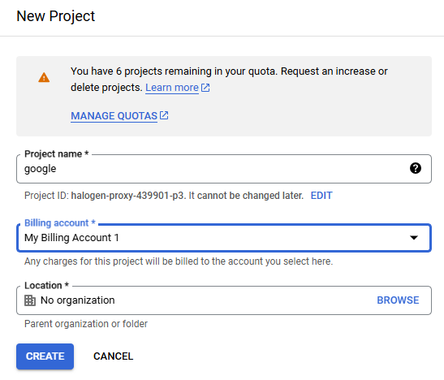

click create

enable billing

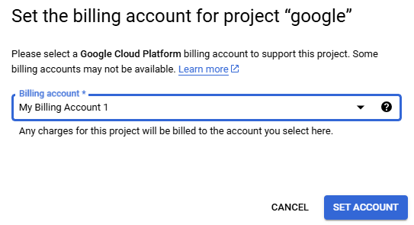

step 2 creates a cloud storage bucket

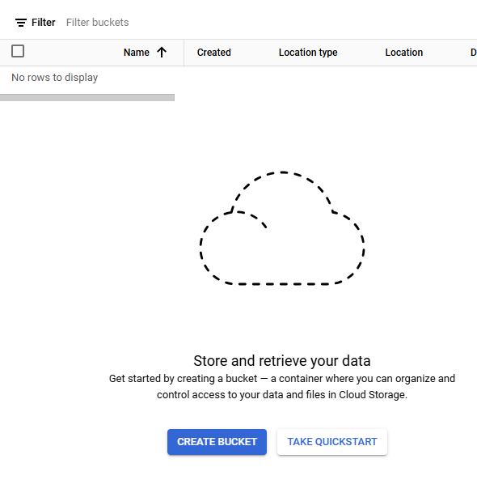

Create global name

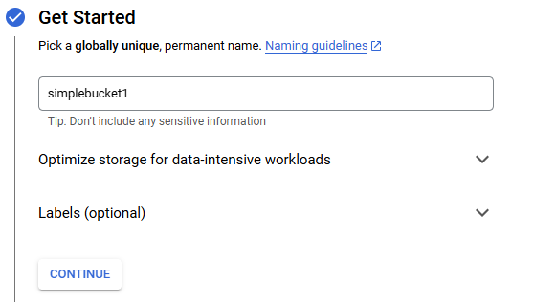

simplebucket1

choose region to store data

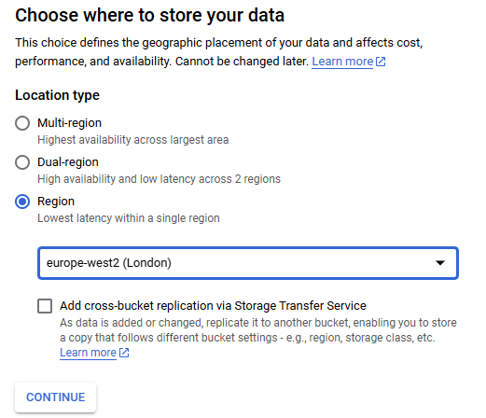

Click create

clear the enforce public access prevention and click confirm

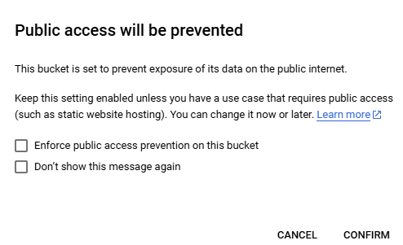

upload the html files in the bucket

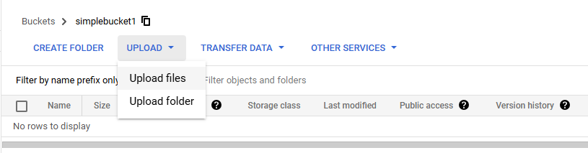

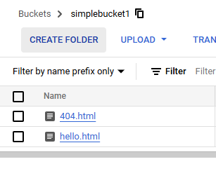

Go in permissions tab

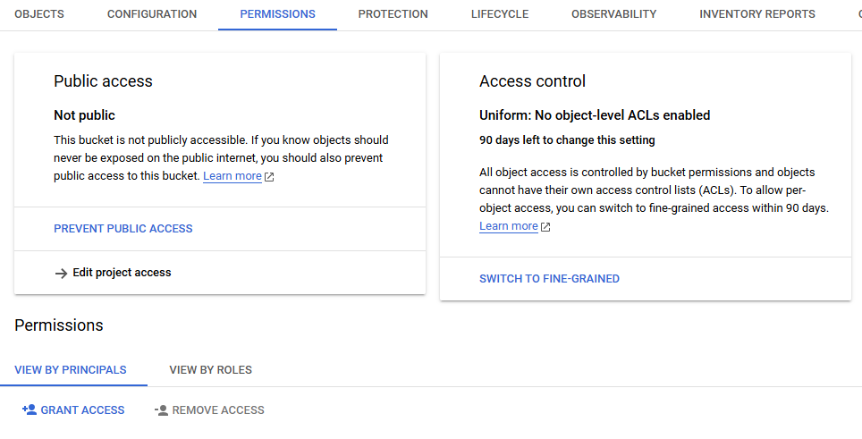

Click on grant access

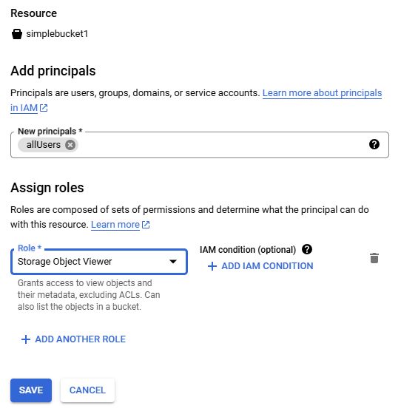

Click save

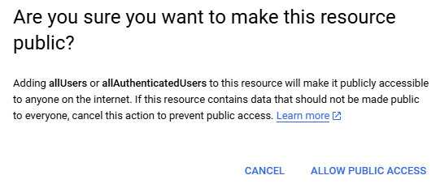

Click Allow public access

Go into bucket click on object overflow menu



Right click on the dotted line



Select copy authenticated url

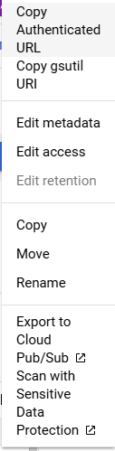

Open new browser and paste the url link and enter

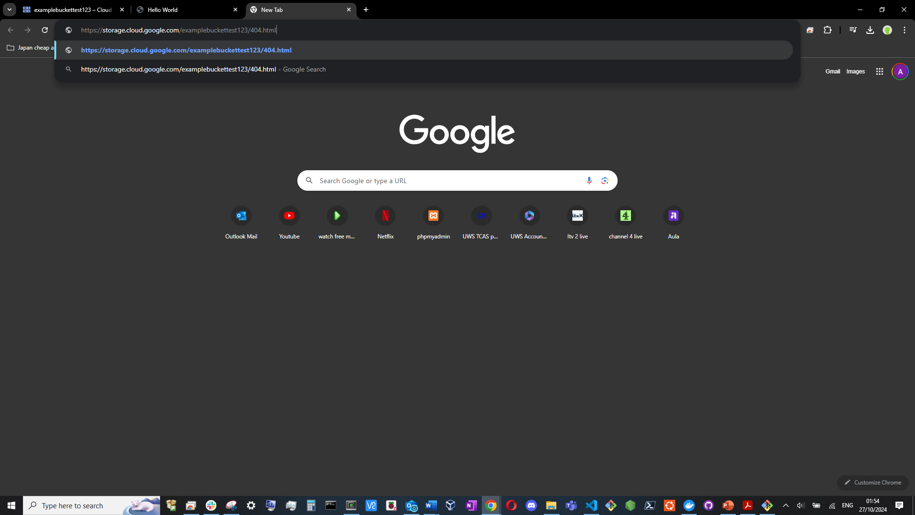

Hello.html



404.html

